Working with Composite Data Types

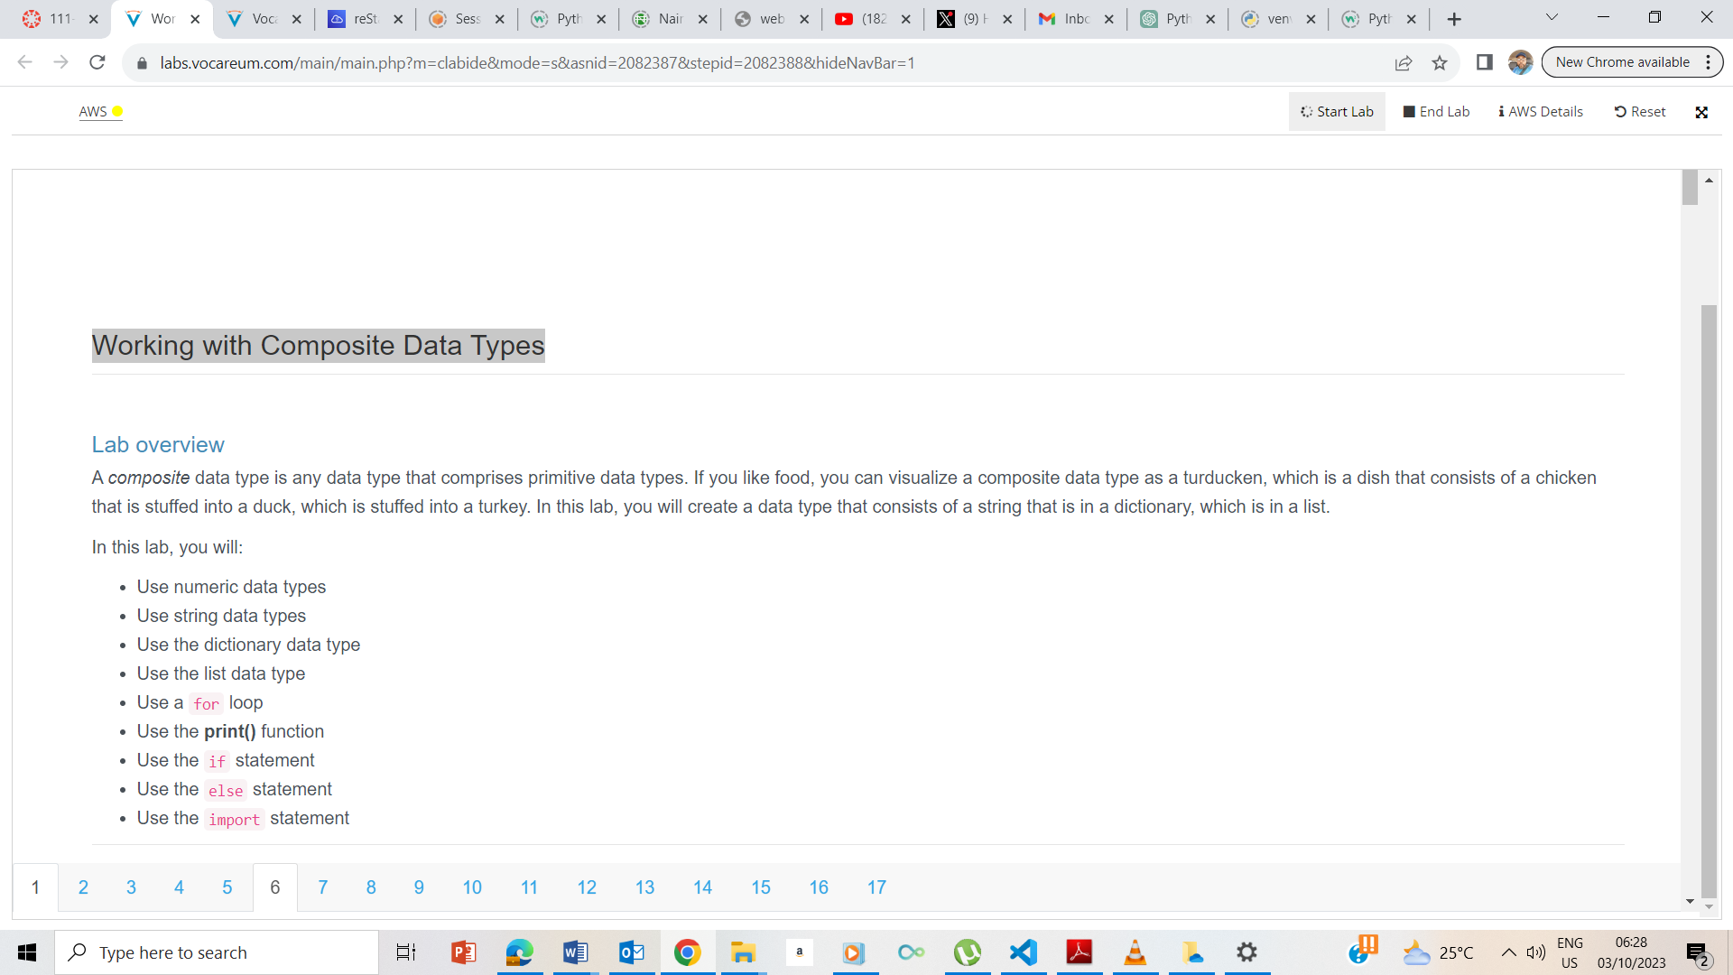

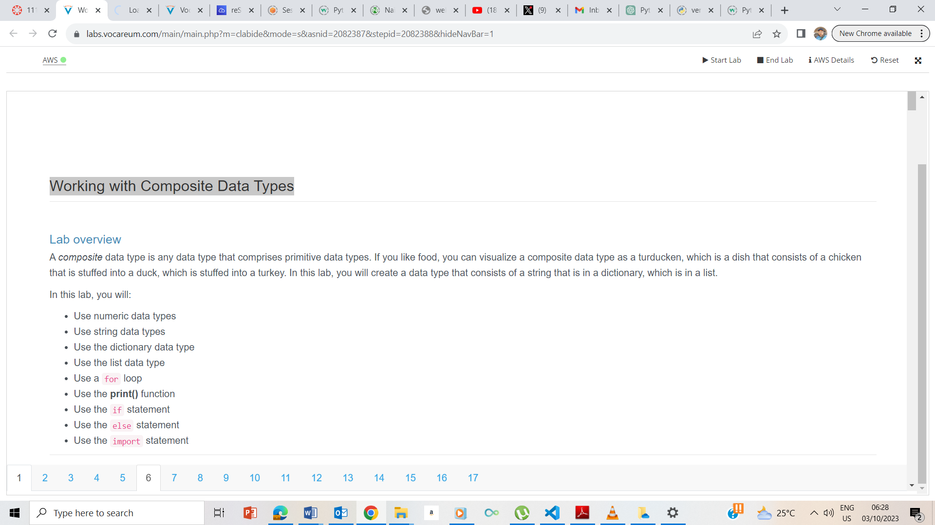

I clicked on start and waited for the AWS button to turn green before clicking on the AWS button to take me to the AWS management console

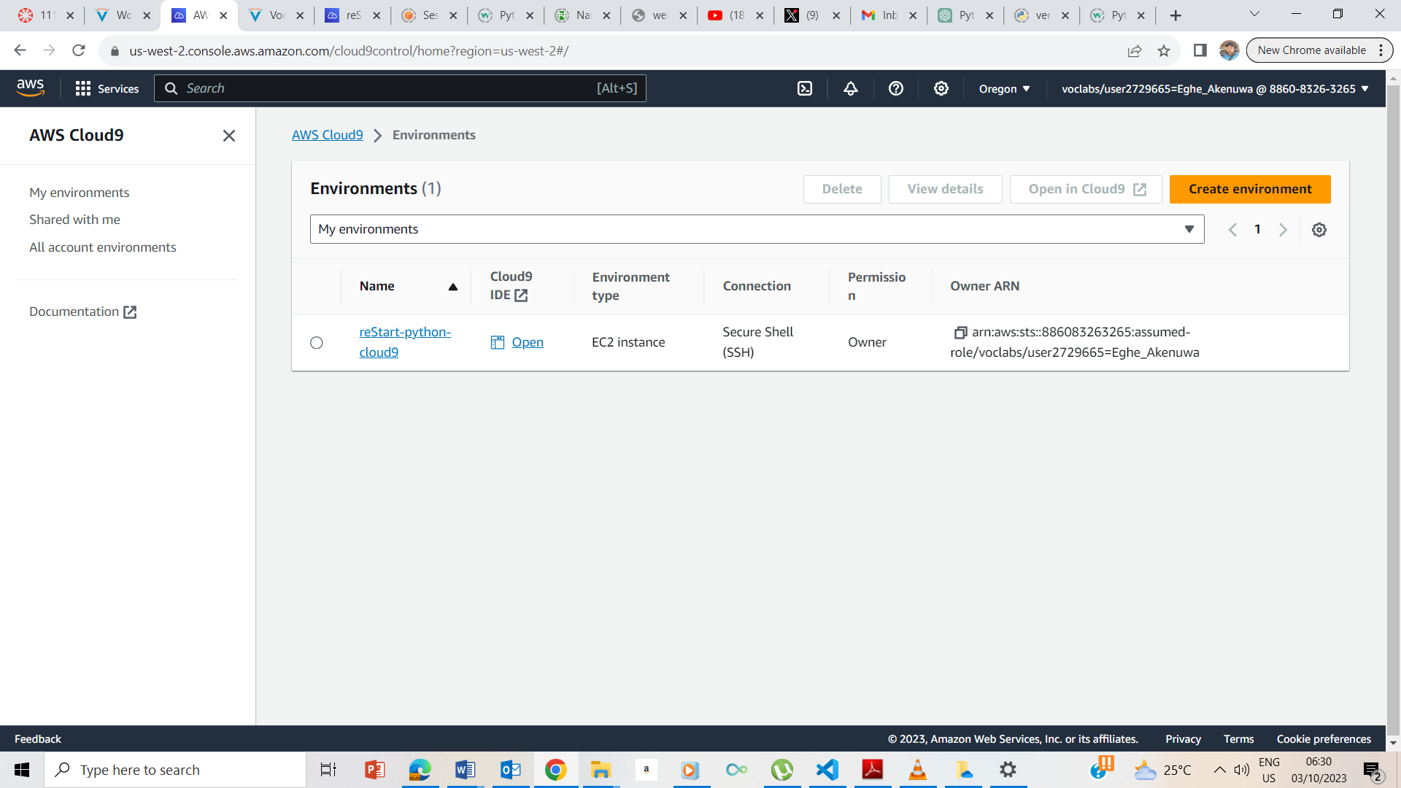

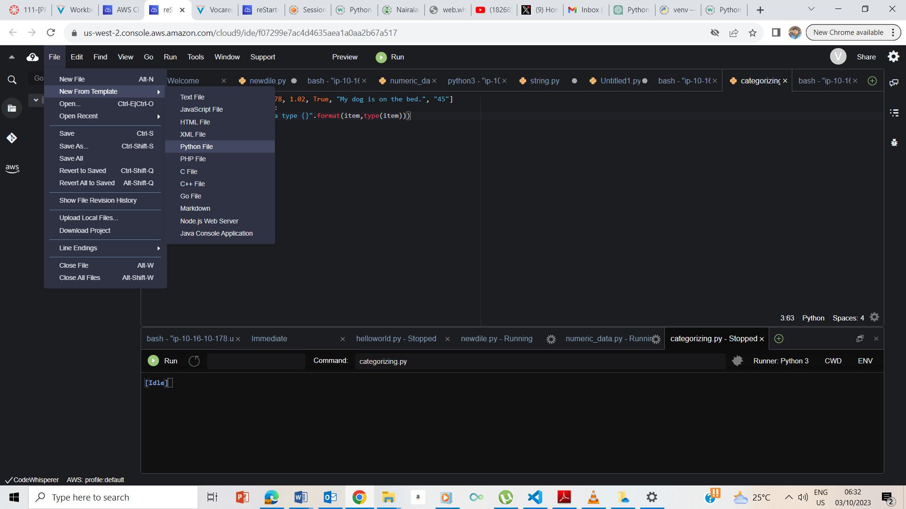

I clicked on Cloud9 and took me to Cloud9 page and I clicked on Open IDE and took me to the Cloud9IDE ; I now clicked on File, Newfrom Template and Python.

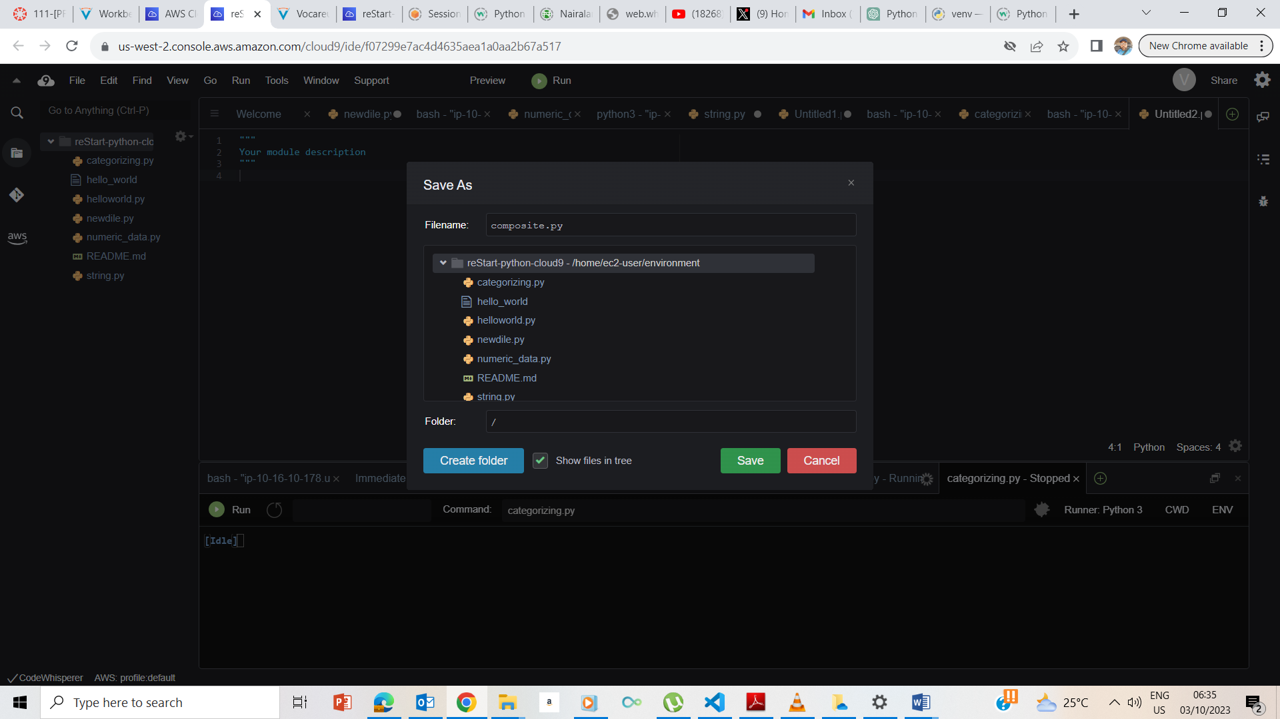

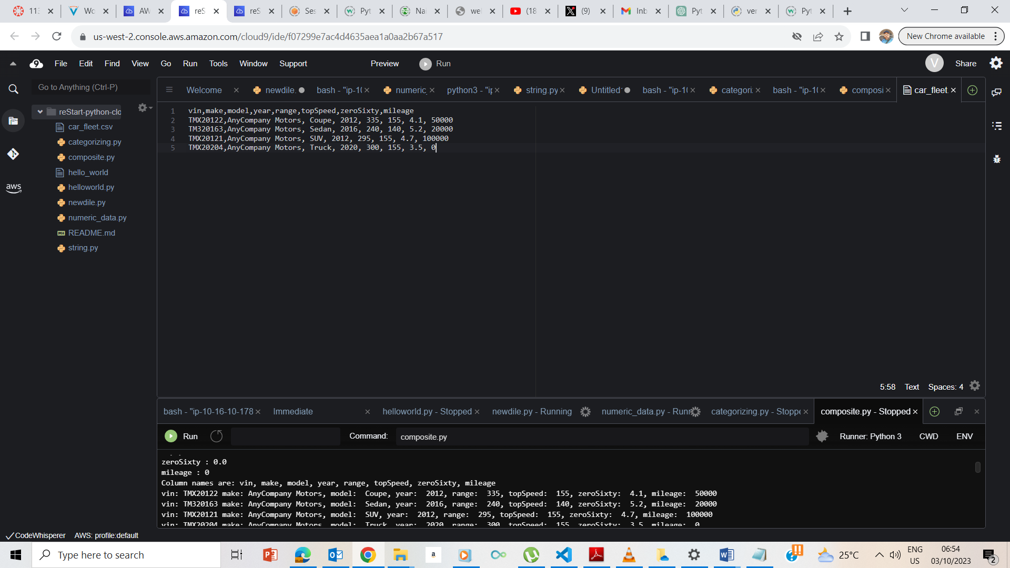

Car_fleet.csv created

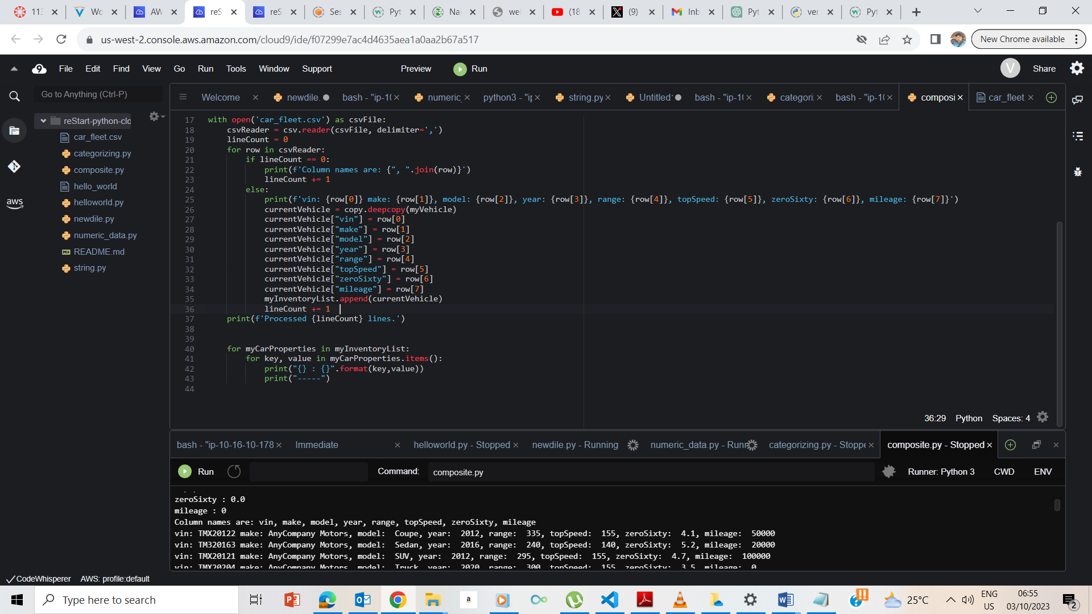

Code inputted

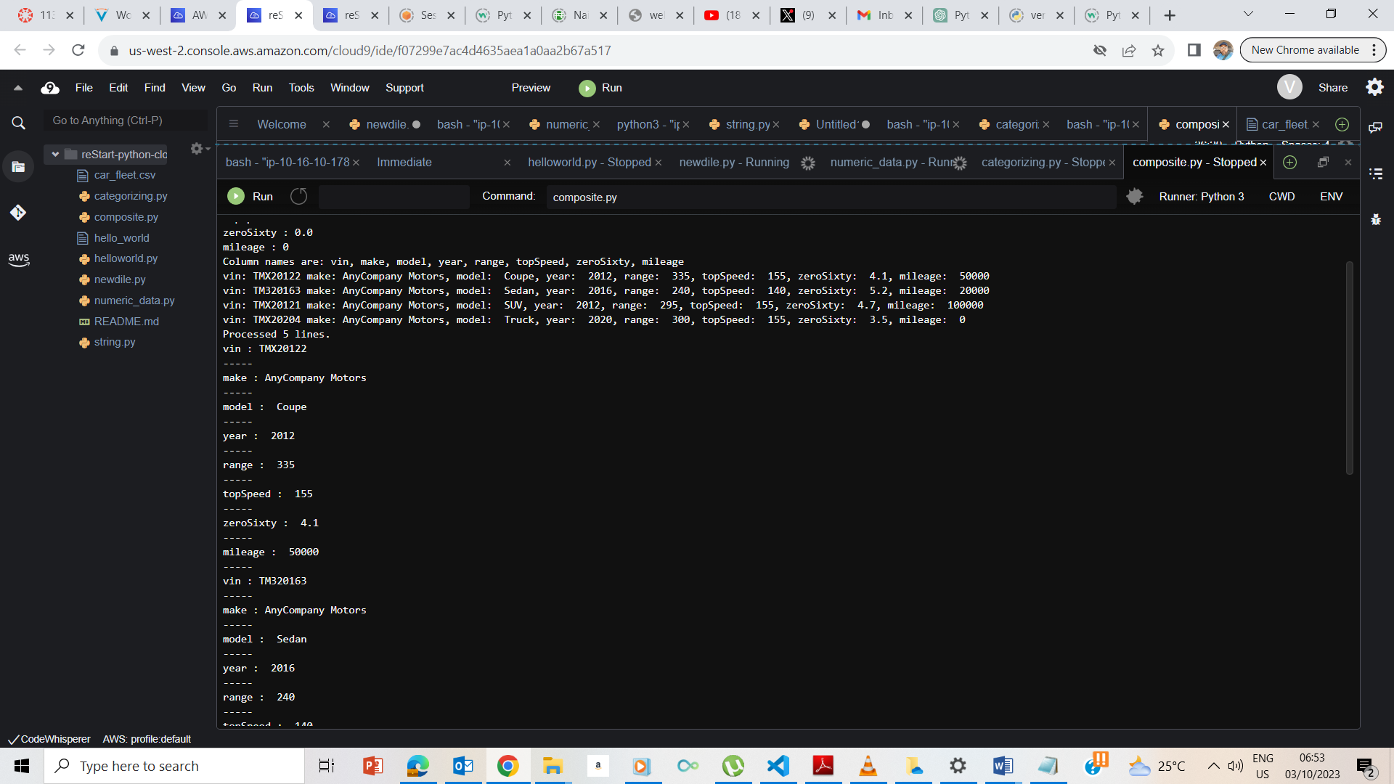

Code ran as expected.

## **End Lab**

